1.

A) Find the shortest distance from G to C

Using the formula

maximize dt

point of invesitigation to ds = 0

dt − ds ≤ lst for edge s -> t

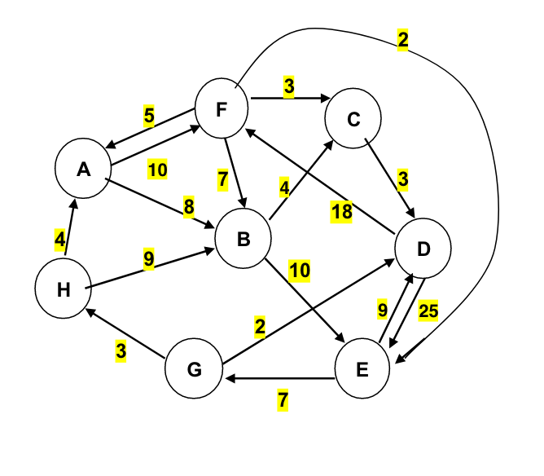

Option 1: G to D to F to C: **23**

Option 2: G to D to F to B to C: **31**

Option 3: G to H to B to C: **16**

Option 4: G to H to A to F to B to C: **28**

Option 5: G to H to A to B to C: **19**

Option 6: G to H to A to F to C: **20**

We can see that Option 3: G to H to B to C: **16** has the shortest route

I also solver this using solver in Excel, below is the copied spread sheet. For part 2, I did the same thing. Spreadsheet is attached an different tabs are labeled to each problem

|  |  |  |  |  |  |  |  |  |  |  |  |  |  |
| --- | --- | --- | --- | --- | --- | --- | --- | --- | --- | --- | --- | --- | --- |
|  | Node |  |  |  |  |  |  |  |  |  |  | |  |
|  | A | B | C | D | E | F | G | H |  |  |  | |  |
| A | 100 | 8 | 100 | 100 | 100 | 10 | 100 | 100 |  | Total Distance | | 16 | |
| B | 100 | 100 | 4 | 100 | 10 | 100 | 100 | 100 |  |  |  | |  |
| C | 100 | 100 | 100 | 3 | 100 | 100 | 100 | 100 |  |  |  | |  |
| D | 100 | 100 | 100 | 100 | 25 | 18 | 100 | 100 |  |  |  | |  |
| E | 100 | 100 | 100 | 9 | 100 | 100 | 7 | 100 |  |  |  | |  |
| F | 5 | 7 | 4 | 100 | 2 | 100 | 100 | 100 |  |  |  | |  |
| G | 100 | 100 | 100 | 2 | 100 | 100 | 100 | 3 |  |  |  | |  |
| H | 4 | 9 | 100 | 100 | 100 | 100 | 100 | 100 |  |  |  | |  |
|  |  |  |  |  |  |  |  |  |  |  |  | |  |
|  |  |  |  |  |  |  |  |  |  |  |  | |  |
| Modify below for each problem | | | |  |  |  |  |  |  |  |  | |  |
|  |  |  |  |  |  |  |  |  |  |  |  | |  |
|  |  |  |  |  |  |  |  |  |  |  |  | |  |
|  | Node |  |  |  |  |  |  |  |  |  |  | |  |
|  | A | B | C | D | E | F | G | H | Total Out | Out-In |  | |  |
| A | 0 | 0 | 0 | 0 | 0 | 0 | 0 | 0 | 0 | 0 | = | | 0 |
| B | 0 | 0 | 1 | 0 | 0 | 0 | 0 | 0 | 1 | 0 | = | | 0 |
| C | 0 | 0 | 0 | 0 | 0 | 0 | 0 | 0 | 0 | -1 | = | | -1 |
| D | 0 | 0 | 0 | 0 | 0 | 0 | 0 | 0 | 0 | 0 | = | | 0 |
| E | 0 | 0 | 0 | 0 | 0 | 0 | 0 | 0 | 0 | 0 | = | | 0 |
| F | 0 | 0 | 0 | 0 | 0 | 0 | 0 | 0 | 0 | 0 | = | | 0 |
| G | 0 | 0 | 0 | 0 | 0 | 0 | 0 | 1 | 1 | 1 | = | | 1 |
| H | 0 | 1 | 0 | 0 | 0 | 0 | 0 | 0 | 1 | 0 | = | | 0 |
| Total in | 0 | 1 | 1 | 0 | 0 | 0 | 0 | 1 |  |  |  | |  |

Using above strategy for part B

|  |  |
| --- | --- |
| G to: | Cost |
| A | 7 |
| B | 12 |
| C | 16 |
| D | 2 |
| E | 19 |
| F | 17 |
| G | N/A |
| H | 3 |

2)

First need to calculate cost be tie and profit (for objective function)

|  |  |  |  |  |
| --- | --- | --- | --- | --- |
| Type of Tie | Selling Price | Labor | Material | PPT |
| Silk=s | 6.7 | 0.75 | 2.5 | 3.45 |
| Poly=p | 3.55 | 0.75 | 0.48 | 2.32 |
| Blend1=n | 4.31 | 0.75 | 0.75 | 2.81 |
| Blend2=c | 4.81 | 0.75 | 0.81 | 3.25 |

We use the last column to formulate

Max(3.45X1+2.32X2+2.81X3+3.25X4)

Problem was solved using excel and solver and is attached in the Problem 2 tab of included excel

|  |  |  |  |
| --- | --- | --- | --- |
| **s** | **p** | **b** | **c** |
| **7000** | **13687** | **13000** | **8500** |

Total benefit

**120060**

3)

|  |  |  |  |  |  |  |  |  |
| --- | --- | --- | --- | --- | --- | --- | --- | --- |
|  |  |  |  |  | CONSTRAINTS | |  |  |
| Start | End | Opt | Cost |  | Start | Cap | inequality | Supply/Demand |
| P1 | W1 | **150** | 10 |  | P1 | 150 | = | 150 |
| P1 | W2 | **0** | 15 |  | P2 | 450 | = | 450 |
| P2 | W1 | **200** | 11 |  | P3 | 250 | = | 250 |
| P2 | W2 | **250** | 8 |  | P4 | 150 | = | 150 |
| P3 | W1 | **0** | 13 |  | W1 | 0 | = | 0 |
| P3 | W2 | **150** | 8 |  | W2 | 0 | = | 0 |
| P3 | W3 | **100** | 9 |  | W3 | 0 | = | 0 |
| P4 | W2 | **0** | 14 |  | R1 | -100 | = | -100 |
| P4 | W3 | **150** | 8 |  | R2 | -150 | = | -150 |
| W1 | R1 | **100** | 5 |  | R3 | -100 | = | -100 |
| W1 | R2 | **150** | 6 |  | R4 | -200 | = | -200 |
| W1 | R3 | **100** | 7 |  | R5 | -200 | = | -200 |
| W1 | R4 | **0** | 10 |  | R6 | -150 | = | -150 |
| W2 | R3 | **0** | 12 |  | R7 | -100 | = | -100 |
| W2 | R4 | **200** | 8 |  |  |  |  |  |
| W2 | R5 | **200** | 10 |  | Total Cost | **17,100** |  |  |
| W2 | R6 | **0** | 14 |  |  |  |  |  |
| W3 | R4 | **0** | 14 |  |  |  |  |  |
| W3 | R5 | **0** | 12 |  |  |  |  |  |
| W3 | R6 | **150** | 12 |  |  |  |  |  |
| W3 | R7 | **100** | 6 |  |  |  |  |  |

Part 2) When the equation is edited for account for no warehouse 2, solver cannot find a solution. The program bottlenecks are the warehouse solution. Warehouse 2 is critical as it connects to P1, P2, P3, P4.



Part 3

Yes, you can do it but it will cost more. You need to add two limits, so that the the total transfer in and out of w2 is less than 100 for each

|  |  |  |  |  |  |  |  |  |  |
| --- | --- | --- | --- | --- | --- | --- | --- | --- | --- |
|  |  |  |  |  | CONSTRAINTS | |  |  |  |
| Start | End | N | Cost |  | Start | Cap | inequality | Supply/Demand | |
| P1 | W1 | 150 | 10 |  | P1 | 150 | = | 150 |  |
| P1 | W2 | 0 | 15 |  | P2 | 450 | = | 450 |  |
| P2 | W1 | 350 | 11 |  | P3 | 250 | = | 250 |  |
| P2 | W2 | 100 | 8 |  | P4 | 150 | = | 150 |  |
| P3 | W1 | 0 | 13 |  | W1 | 0 | = | 0 |  |
| P3 | W2 | 0 | 8 |  | W2 | 0 | = | 0 |  |
| P3 | W3 | 250 | 9 |  | W3 | 0 | = | 0 |  |
| P4 | W2 | 0 | 14 |  | R1 | -100 | = | -100 |  |
| P4 | W3 | 150 | 8 |  | R2 | -150 | = | -150 |  |
| W1 | R1 | 100 | 5 |  | R3 | -100 | = | -100 |  |
| W1 | R2 | 150 | 6 |  | R4 | -200 | = | -200 |  |
| W1 | R3 | 100 | 7 |  | R5 | -200 | = | -200 |  |
| W1 | R4 | 150 | 10 |  | R6 | -150 | = | -150 |  |
| W2 | R3 | 0 | 12 |  | R7 | -100 | = | -100 |  |
| W2 | R4 | 50 | 8 |  |  |  |  |  |  |
| W2 | R5 | 50 | 10 |  | Total Cost | **18300** |  |  |  |
| W2 | R6 | 0 | 14 |  |  |  |  |  |  |
| W3 | R4 | 0 | 14 |  | Limit warehouse | |  |  |  |
| W3 | R5 | 150 | 12 |  | w2 | 100 | <= | 100 | input |
| W3 | R6 | 150 | 12 |  | W2 | 100 | <= | 100 | out |
| W3 | R7 | 100 | 6 |  |  |  |  |  |  |

4) Work is in attached excel spread sheet, results are summarized below

for part A)

|  |  |  |  |  |  |  |  |
| --- | --- | --- | --- | --- | --- | --- | --- |
|  |  |  |  |  |  |  |  |
| Coin Value | 1 | 5 | 10 | 25 |  |  | Change |
|  |  |  |  |  |  |  | 202 |
| Count amount | 2 | 0 | 0 | 8 |  |  | Desired |
|  |  |  |  |  |  |  | 202 |
|  |  |  |  |  |  |  | Total Coins |
|  |  |  |  |  |  |  | 10 |

It takes 10 coins 2 at value 1 and 8 at value 25.

|  |  |  |  |  |  |  |  |  |
| --- | --- | --- | --- | --- | --- | --- | --- | --- |
| Coin Value | 1 | 3 | 7 | 12 | 27 |  | Change |  |
|  |  |  |  |  |  |  | 293 |  |
| Count amount | 0 | 0 | 2 | 3 | 9 |  | Desired |  |
|  |  |  |  |  |  |  | 293 |  |
|  |  |  |  |  |  |  | Total Coins |  |
|  |  |  |  |  |  |  | 14 |

It takes 14 coins 9 at value 27, 3 at value 11, 2 at value 7.